**Find the Output**

**Send Feedback**

What will be the output of the code given below -

<!DOCTYPE html>

<html>

<head>

<style>

body {

background-color: #f1f1f1;

}

p {

margin: 0;

}

p::first-line {

font-size: 1rem;

font-family: monospace;

}

p.name::first-letter {

color: #ff0000;

font-size: 2rem;

}

</style>

</head>

<body>

<p class="name">The Divine Tales</p>

<p>In a small room in a once-abandoned government building, a young man, no more than eighteen years of age, was standing in a metal tub as two attendants tended to what seemed to be important preparations.</p>

</body>

</html>

[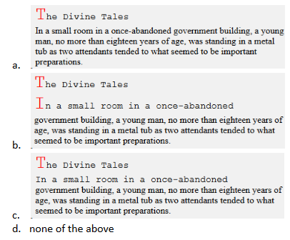](https://ninjasfiles.s3.amazonaws.com/0000000000001697.png)

Ans: c